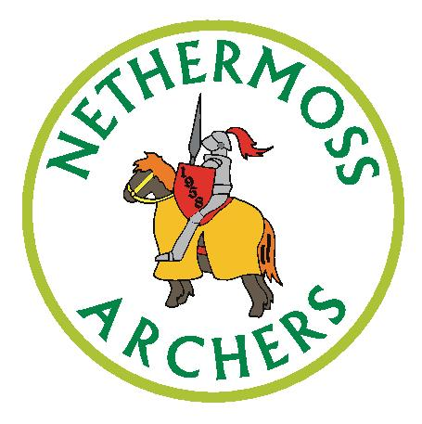

Nethermoss Archers Club Newsletter January 2020

This is a trial edition of what might become a regular newsletter to club members. We are aware that not everyone keeps up with the Club through the social media groups so we are considering an email newsletter that will include important dates and information as well as club news and other information that might be of general interest to members.

If you have something to be included in the next edition, then please let us know! Any feedback will be welcomed. We would particularly welcome views on whether it is worth putting time and effort into producing a regular newsletter along these lines.

Indoor Shooting

Unfortunately, our indoor shooting has been disrupted during January due to the work being carried out in the Edge Hill Sports Hall. Hopefully the work being carried out on the heating system will mean we are more comfortable in future. We return to (mostly) normal Wednesday and Saturday shooting from Wednesday 22nd January, but please note the dates below when our Saturday sessions have been moved, by Edge Hill, to Sundays. Please note that Wednesdays tend to be quieter so if you want to experiment with form or tuning that’s your day!

Juniors!

Please keep your scores up to date in the records book so that we can keep up our excellent record in the Northern Counties Archery Society. Please also keep you progress awards up-to-date.
Improve Your Shooting!

Valda has highlighted a series of excellent videos available on YouTube that covers recurve shooting form and bow tuning. Search for ‘Jake Kaminski’. As always please don’t hesitate to ask any of the Club ‘old timers’ if you have any questions on shooting form or tuning.

Club Dates for Your Diary

Indoor Shooting at Edge Hill University, Wilson Sports Hall, Wednesdays 7pm to 9pm, Saturdays 1.30pm to 4.30 pm. Unless otherwise noted below.

Wednesday 22nd January – Indoor shooting re-opens, 7pm - 9pm

Saturday 1 February – session moved to Sunday 2nd February

Sunday 2nd February – shooting 1.30pm - 4.30pm. Club handicap and postal shoot
Saturday 7th March – Club handicap and postal shoot

Saturday 14th March – session moved to Sunday 15th March

Sunday 15th March - shooting 1.30pm to 4.30 pm

Saturday 28th March – last indoor shooting 1.30pm to 4.30 pm. Club Indoor championships

Thursday 2nd April – outdoor shooting reopens at Hurlston Hall. Normal club shooting, Saturdays 1pm to around 4pm, Tuesdays and Thursdays 5pm to dusk – subject to weather and key holder availability.

Beginners Courses

We are now taking bookings for our first Beginners Course of the outdoor season starting on Saturday 25th April at Hurlston Hall. Please spread the word to your family & friends! See our website for more details. Any help from members with our Beginners Courses is always much appreciated!

Could those of you who have borrowed bows from the club please return them now, thanks.

Local Competitions

Sunday 26th January – Wigan & Orrell Archers, Portsmouth, Bamber Bridge

Sunday 9th February – Chorley Bowmen, WA Combined, Bamber Bridge

8th March, Spinners Mill Archers, WA 18, Spinners Mill, Leigh

5th April, Spinners Mill Archers, WA 18 and head-to-head, Spinners Mill, Leigh

26th April, Blackpool Bowmen, Junior Open Metrics, Blackpool

Entry forms are available from the Lancashire Archery Association, https://www.lancashire-archery.org/2020, where there is also a more comprehensive listing of competitions.
Email & Social Media

Email – nethermossarchers@gmail.com

Web site – www.nethermoss.co.uk

News blog – nethermossnews.blogspot.com

Facebook Group – ‘Nethermoss Archers’ (closed group, membership on request)

WhatsApp Group – Nethermoss Updates & News, membership on request

Instagram – Nethermoss Archers (Private account – follow on request)

